IT Project Procurement

Standard Base (System Domain) Functionality

# Document

## **Synopsis**

All systems are the combination of a minimum of two domains: a Business Domain, for which the system is being developed, and an supporting ITC Domain used to support the business domain.

This document describes the capabilities and functionality expected to be provided to meet ITC Domain needs, so that it can efficiently support the Business Domain over the service’s lifespan.

## **Description**

Title: IT Project Procurement – Standard Base (System Domain) Functionality

Author: Sky Sigal, Solution Architect

Date: 18/05/2021

## **Distribution**

Distribution/Review List:

* Amy Orr, Data Architect
* Diane Simpson, Infrastructure Architect
* Brad Atte Le Crouche, Solution Architect
* Stuart McGrigor, Solution Architect
* Dries Venter, Cloud Infrastructure Specialist
* Werner Van der Merwe, Automation Lead
* Yujia Huang, Security Specialist, Contractor
* Jeff Grove, Security Specialist, Contractor
* Sean Torley, ICT Change & Transition
* Sally Murrey, ICT Change Advisor
* Grayson Mitchell, Manager, BE&S ICT Strategy Planning & Architecture

## **Conventions**

### **Terms**

The Appendices include a Glossary of Terms to assist understand this document.

### **Diagrams**

Where applicable, diagrams are developed using ISO-*, Archimate, UML or appropriate industry standards and conventions.

# Context

## Background

System delivery risk is diminished by breaking the system’s design into Logical Modules, each specific to a single Domain of knowledge.

All systems are the combination of a minimum of two domains: a Business Domain, for which the system is being developed, and an underlying ITC Domain used to support the business domain.

This document describes the capabilities and functionality expected to be provided to meet ITC Domain needs, so that it can efficiently support the Business Domain over the service’s lifespan.

# Base System Logical Module Functionality

The Base System Logical Module is required to be addressed before the Business Specific Logical Module can be delivered.

The Base System Logical Module manages several coordinated sub-domains requiring management: Technology Integration, Configuration and Monitoring, Users, Groups and Permissions.

The Functionality areas within the Module are listed in the diagram below.

It is highly unlikely that all the functionality areas will require completion in their entirety before subsequent work is addressed. But some aspects are required first.

The architect and product manager work together to prioritise effort by balancing Stakeholder expectations versus architectural impact of leaving work till later.

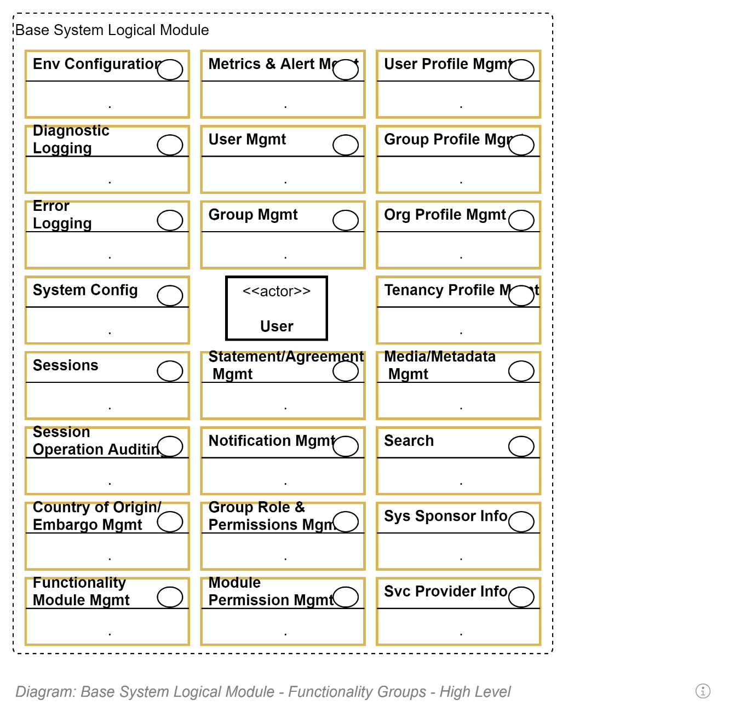

Environmental Configuration

System Information

Sessions

# Functionality

## Logical Modules

# System Logical Module

## Deployment Services

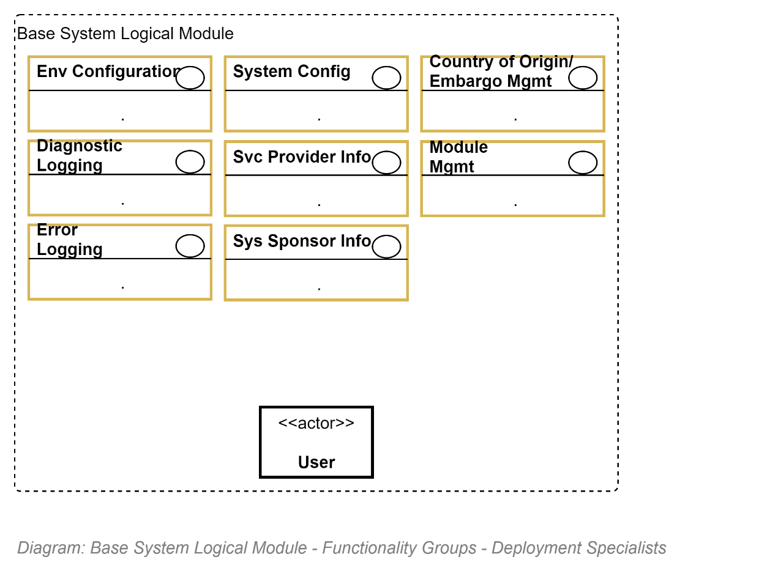

Deployment Specialists will benefit from the above functionality being available to them:

### Mutable Environment Configuration Functionality

Deployers require the capability to configure environment-specific component integration without re-compiling the code. Settings include the url to storage devices, databases and other components must have access to in order to function correctly.

*Note: it is common – due to perceived need for expediency at the start of projects – for the functionality to be overused, as opposed to using it minimally, developing Mutable Settings instead.*

### Diagnostics Logging Functionality

Deployment specialists require the capability to capture diagnostics logging messages to troubleshoot failed deployments.

*Note: it is common -- for perceived need for expediency at the start of projects – automatic configuration log rotation/reuse is skipped, until it becomes understood as an avoidable storage cost.*

### Error Logging Functionality

Deployment specialists require the capability to capture unexpected exceptional behaviour, in order to query whether the deployment was successful or not. Logging errors in a database permits them to analyse often specific errors occurs, if there is any pattern to the occurrence, etc.

### Metrics/Alerting Functionality

Deployment specialist stakeholders require the capability to configure metric collection to trigger resource alerts for themselves as well as security alerts for monitoring specialist stakeholders.

*Note: it is common -- for perceived need for expediency at the start of projects – metric collection is not collected until later, making alerting unavailable. This usually negatively impacts Monitoring options.*

*Note: Common resource metrics should be configured to reflect spot and duration values for Memory use, CPU use, Users, Requests, Throughput, Errors. Common security metrics should be configured to reflect spot and duration values of Resources accessed/viewed, Resources edited per user. Common alerts should be start with alerting to DNS attacks, brute force attacks, excessive access to resources.*

*Consider collecting the following metrics to develop alerts:*

* New Sessions per Duration
* New Sessions Count since last Reset
* Current Session Count
* Current Unauthenticated Session Count
* Current Authenticated Session Count
* Current User Count
* API I/O Throughput per Duration
* DB I/O Throughput per Duration
* Queries per Request Count per Duration
* Exceptions per Duration
* Exceptions Count since last Reset
* Queries per Duration
* Queries Count since last Reset
* SMTP Notifications Count per Duration
* SMTP Notifications Count since last Reset

### Service Information Functionality

Deployment Specialists require the capability to test assumptions by querying the name of the software, its exact version, before searching for solutions.

*Note: it is common – due to perceived need for expediency at the start of projects – for the functionality to not be provided until later.   
The information is often hard-coded.*

### Service Sponsor Information Functionality

Discoverability of the service on the web and end users trust is improved when systems – whether purchased or custom developed – are branded to reflect the organisation’s name, visual identity.

The information should not be hard-coded or immutably configured: sponsorship changes over a solution’s lifespan for many reasons. For example, branding is updated, departments are merged, or their names are changed to better reflect changed purpose.

*Note: it is common – due to perceived need for expediency at the start of projects – for the functionality to not be provided until later.   
The information is often hard-coded.*

### Service Provider Information Functionality

A 3rd party service (e.g.: a CMS) needs to be named & branded with media to reflect the organisation that is providing the service to end users. Contact channel information is often included.  
It is not uncommon for the Service Provider is often distinct from the Service Sponsor – the Organisation that funded the development.

*Note: it is common – due to perceived need for expediency at the start of projects – for the functionality to not be provided until later. Service Sponsor Information is used instead until then.*

### System Settings Functionality

Because Environment Configuration settings are immutable (unchangeable) without redeploying the system, it is best practice to keep as many settings mutable (dynamically updateable), by persisting them in the system’s primary database.

*Note: it is common – due to perceived need for expediency at the start of projects – for the functionality to not be provided until later.   
Over-reliance on Environment Configuration settings is common.*

### Embargo Settings Functionality

By national law, systems are not to be made available to embargoed countries.

A deployment specialist will be required to configure this behaviour.

If the system is behind a corporate firewall this exclusion can be handled externally to the system itself. If the service has a SaaS based component, this requires in-system configuration and enforcement.  
 *Note: it is common – due to perceived need for expediency at the start of projects – for the functionality to not be provided until later. When it is enforced, it should be a mutable System Setting (not an immutable Environment Configuration).*

### Module Management Functionality

Deployment Specialists are often requested by Business User Specialists to deploy new or update existing Functionality packages (Physical Modules).

Deployment Specialists require the capability to analyse what modules have already been installed, what version, and change their state for disable to enabled, and vice versa.

*Note: it is common – due to perceived need for expediency at the start of projects – for the functionality to not be provided ~~until later~~ as most software development is not managed well enough to be modularly deployed[1].*

## Monitoring Services

Whatever the business purpose being deployed, there remains constant risk that unexpected behaviour can occur due to a number of possibilities: incorrectly configured or behaving network, environment, system, components, users misbehaviour, resource aging.

### Diagnostics Functionality

Until alerting for setting up custom user interfaces are developed it is common for monitoring services to require Diagnostics logs to be configured correctly and exported to an organisation SIEM for further analysis there.

### Session and User Management Functionality

If malevolent behaviour is observed and considered a risk, it is important that Monitoring Services can shut down a User’s Session and disable a User account until mitigations are put in place.

### Session Operation Auditing Functionality

Monitoring Specialist use activity auditing recording and querying functionality to actively or forensically determine what a User is doing, in order to determine if the actions are malevolent.

### Group Role & Permission Management Functionality

Monitoring Specialists check the Role of a User within a Group to determine whether they should be accessing a Resource.

### Alerting Functionality

To be alerted where possible to impeding issues and be able to query the system for additional information, diagnostics functionality is required by Monitoring Specialists.

* Alerting:
  + Alerting is handled exterior to the service.

## Maintenance Stakeholder Functionality

Maintenance Specialists perform operations to keep the system in running order.

They investigate settings, but should not change them, leaving the changes to the Deployment Specialists to add them to the Deployment Pipeline for the next deployment.

As maintainers, they must have access to most areas of functionality within the Base System Logical Module to ensure the system was deployed as expected before the delve deeper to find the cause for unexpected behaviour.

### System Configuration Functionality

Maintainers sometimes must check the configuration of the target environment to ensure Integration settings are correct.

### Diagnostics Logging Functionality

Maintainers often require looking at log files to glean an explanation for unexpected behaviour.

### System Configuration Functionality

Maintainers sometimes must check mutable System Configuration Settings to ensure that another user has not mis-configured the system.

### Session Operation Audit Functionality

Maintainers may require the capability to review Audit trails to understand the sequence of actions that may be the cause for abnormal system behaviour.

### Module Management Functionality

Maintainers may require reviewing whether Modules have been kept up to date to work with the latest version of the host system, or have been inadvertently disabled.

### Alert Functionality

If the system’s alerting functionality is robust and easily configured, some of the checks could be automated as alerts.

### Notification Functionality

If the system needs to be taken down for backup and/or restoration or other work, notifications can be sent to all system users.

*Note:  
For the sake of expediency, this functionality is often omitted as large organisations have the processes in place to alert users to upcoming change. Note that this functionality is not available for external, client users.*

### Service Sponsor and Service Provider Information

Maintainers will be able to see the above information at the top of their user interfaces.

### Users, Groups, Group Roles, Permissions Information Functionality

Maintainers require the capability of looking up users, understanding what roles they belong to, their permissions, in order to add to their understanding as to how a resource was changed by a User.

### Search

Maintainers use Search to quickly find Resources that a User may have updated.

## Operations Services

Support Services – described later - on the front-line handle user requests of various kinds. The most common request – by a wide margin – is assistance with lost credentials, needing a password reset.

* Tenancy Management:
  + Add, Update & Configure, change State, and logically Delete Tenancies.
* Media/Resource Management:
  + Add, Update, change the State of, and logically Delete Media Collections
  + Add, Review, Update, change the state of, Replace and logically Delete Media/Resources within Collections.

## Customer Services

#### User Management

Users expect functionality beyond the specific business functionality (described next).

* User Identity Profile Configuration
  + Update their Display Name
  + Update their Identity Bio
* Group Identity
  + Update the Role Description within a Group
* Media/Resource Management
  + Add, Update, Submit for Review, logically Delete, Resources in Development.

### Authorisation Management

### Resource Discovery Management

## Support Services

Support Services on the front-line handle user requests of various kinds. The most common request – by a wide margin – is assistance with lost credentials, needing a password reset. But they perform other operations on users behalf as well.

# Business Logical Module

1. Even when modular Domain Driven Development OO based development practices have a proven track record of lowering design and development cost, lowering error and therefore correction rates, lowering the rate of missing delivery schedules, increasing the responsiveness to end user issues and desires.